Shalom Community APPLICATION

A collaborative effort of Wheaton College
Residence Life and the Office of Multicultural Development
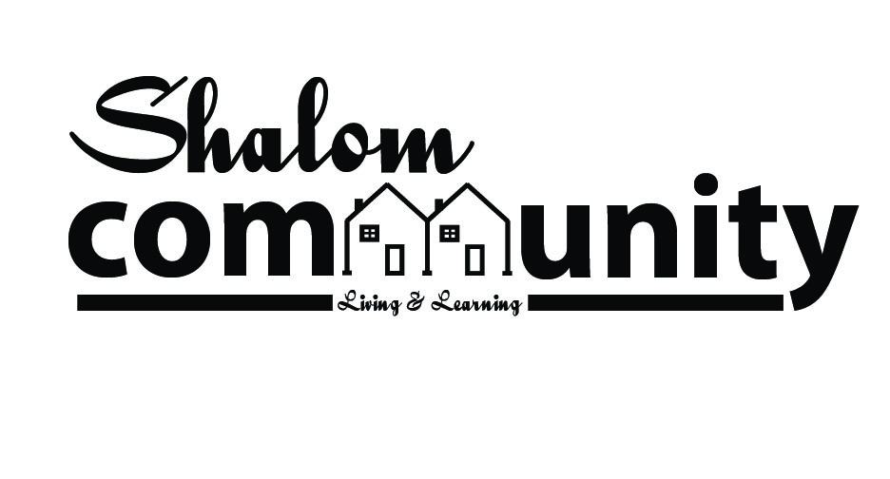

Shalom’s Mission
The Shalom Community contributes to students becoming whole and faithful Christians who pursue interracial healing and challenge racism within their spheres of influence.

Founding Vision
To cultivate a Biblical framework for diversity, cross-cultural restorative dialogue, celebration of ethnic and racial diversity, and self-awareness within the context of a Christ-centered, multi-racial living learning community, including academic curriculum, educational programming,
and Christian fellowship.

The deadline for applications is Wednesday, February 20th 2019 no later than 4PM.
Applications should be turned in to the Office of Multicultural Development in Lower Beamer or sent in electrically (multicultural.development@wheaton.edu).

Interviews will take place the week of February 25th. Please sign up for an interview time when you turn in your application to the OMD.

Decisions will be made and all applicants will be notified no later than
Monday, March 4th

CONTACT INFORMATION FOR MORE DETAILS OR ELECTRONIC COPY OF THE APPLICATION
Residence.life@wheaton.edu OR multicultural.development@wheaton.edu

Who Should Apply?
We are looking for Wheaton College students who will be juniors and seniors and who desire to commit to and fully engage in an intentionally diverse living community during the 2019-2020 academic year.
The Shalom Community invites students of all racial, ethnic, and cultural backgrounds to apply. The community will be enriched by the intersection of students’ individual journeys, cultural awareness, and/or experiences.
Commitments
- Participate in 3 B quad (spring 2019) Orientation Meetings
- Live in the community for the entire 2019-2020 academic year
- Participate in and prepare for a weekly meeting/activity/dinner (This will most likely be on Mondays from 3:45 – 5:45 pm)
- Move into the community by Saturday, August 24th at 5pm
- Attend kick-off community cookout with GRA Saturday, August 24th at 5:30pm
- Participate in a beginning of the year retreat Sunday, August 25th at 3:00 pm through Monday, August 26th, 2019 at 5:00 pm.
- Collaborate with campus organizations/departments to host a living area event at least once a semester
- Participate in community engagement: Students will take part in shaping their experience by actively building relationships with members of Shalom in casual and formal settings
- Enroll in the following Fall semester course: SOC 337 Racial and Ethnic Relations (or an alternative class addressing race with permission from the staff)
- Uphold the Wheaton College Community Covenant

FAQs
I am interested in talking about diversity, but it’s all new to me. Can I still apply?
Yes! Our purpose is to create a safe place for each student to learn, grow and be challenged no matter where he or she is on their individual journey.
Do I have to be involved with OMD or Solidarity to apply for the house?
No. The Shalom Community is a joint effort between Residence Life and the Office of Multicultural Development. All rising juniors and seniors are welcome to apply.
I am not a person of color. Can I apply?
Yes! The objective of this community is to bring together a variety of people, perspectives and experiences to walk through these things together.
Where will these houses be located?
Historically, the Shalom Community has been located at 510 and 520 Sears Ln. The houses are next to each other and share a backyard.
What is the cost to participate?
There are no additional costs to participate apart from standard Wheaton College housing costs.
Will the houses be coed?
No. There will be two Wheaton College owned living spaces within close proximity to one another— ideally one female house and one male house.
I’m already in a leadership position. Can I still participate?
Yes. However, we encourage you to examine how many commitments you will have next year.
I am interested, but I plan on doing study abroad or HNGR during the 2019-2020 school year. Can I still participate?
No. The community will only be available to students who can commit to one full academic school year.
I am interested, but I’m an athlete. Can I still participate?
Yes, with the expectation that the student will fully participate in the community commitments. It will be important that any athlete in the house communicate with their coaches and the Peer Program Leader (PPL) regarding schedules prior to the start of their season or the school year.
What is the rooming situation?
The houses are set up as double rooms. Roommate pairs will be decided by the end of the spring.
Shalom Community Application
(Please complete and turn in this page along with short answers to questions on the following page by Wednesday, February 20th at 4pm in the OMD)
About You
Name:__________________________________________________________________
Gender:_____ Age:_____ ID #:______________ CPO Box #: _______________
Email Address:_________________________________ Phone #:_________________
Summer Address:________________________________________________________
Permanent Address (if different from summer):_______________________________
Current living area:______________________________________________________
Do you know anyone else who is applying? Please list their names below:
1._______________________________ 2.__________________________________
3._______________________________ 4.__________________________________
5._______________________________ 6.__________________________________
Are you able to commit to the items listed on page 1 under “Commitments”? If no, please explain. Attach an additional page if needed.
________________________________________________________________________________________________________________________________________________________________________________________________________________________
Academics
Class standing as of Fall 2019:______________________________________________
Major(s):_________________________________ Minor(s):_____________________
How many credit hours do you plan to take during the Fall 2019 semester?________
Anticipated Graduation Date: ______________
Short Answer Questions
Please provide typed responses of no more than 250 words for each of the following questions.

- What biblical ideas [principles] or examples influence your views and behavior about diversity or community?
- How have these principles affected you in tangible ways?
- Why are you interested in being part of the Shalom Community? What do you hope to gain and offer, and what are you concerned about?
- What has been your experience or view on the conversation regarding race and culture?
- What other commitments have you made for the coming school year (please include work, church, on and off campus commitments, etc.)?

Below is information regarding the leadership role of the Peer Program Leaders (PPL) of the Shalom Community. If you are interested in applying, please pick up and complete the additional application also due on Wednesday, February 20th
Peer program leader
shalom community
Part-Time Position

Responsibilities:
In collaboration with the OMD and Residence Life, the Peer Program Leader (PPL) serves the Shalom Community by being the student leader who fosters community through caring relationships, facilitation of community building events, initiation of educational opportunities to grow in multicultural awareness and action to accomplish the goals set forth for the Shalom Community. The PPL works in collaboration with the OMD/900 College Ave GRA, the Director of the Office of Multicultural Development and the Residence Director of the Apartments and Houses. This is a paid position.

Duties:
1. Encourage house members’ growth toward wholeness in Christ, maturity in thought, speech and behavior, and in their understanding of living together as members of Christ’s Body.
2. Listen and respond to student concerns, making referrals to other campus resources when necessary.
3. Develop relationships with each student through one on one connections during the fall and spring semester.
4. Organize the weekly Shalom Community meetings in collaboration with the staff.
5. Meet individually with the OMD GRA on a bi-weekly for further training, advice and support.
6. Meet bi-weekly with the OMD GRA and other PPL for training, support and program development.
7. Clarify and hold students accountable to follow the procedures, policies, and traditions of the Shalom Community and of Wheaton College.
8. Establish and maintain community expectations for life together.
9. Initiate informal community events to foster organic dialogue and learning as a community.
10. Address conflict in the house through following Matthew 18 and pulling in staff when necessary.
11. Other duties as assigned by the staff.

Qualifications:
1. Evidence of Christian character and commitment
2. A desire to encourage students to develop into whole and effective servants of Christ
3. Ability to engage and address issues of diversity in Christ-centered and collaborative ways
4. Ability to relate to students and staff
5. Must understand and support the Community Covenant
6. Clear communication skills
7. Leadership potential
8. Must have no other major time commitments beyond being a student and a PPL

